Name: Arun Sharma

Date: 06/22/2024

Assignment: [Assignment: MySQL Install] Module 4.2 Assignment of (Module 4: MySQL + PyCharm Installation)

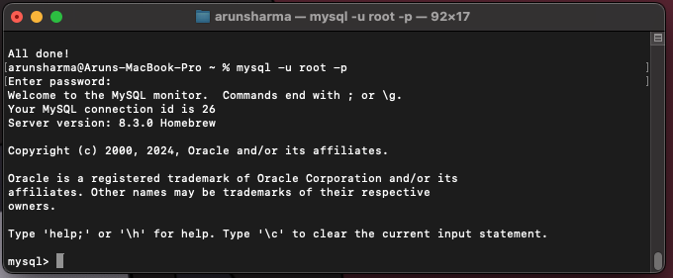

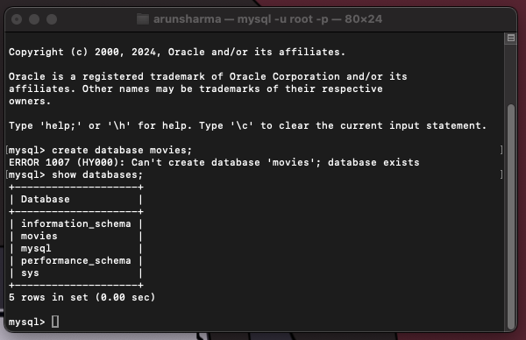

- [During the process of reinstalling MySQL on my Mac, I encountered the error "1007 (HY000): Can't create database 'movies'; database exists." This error occurred because the 'movies' database had already been created during my initial installation attempt.

Initially, when I attempted to use MySQL with the command mysql -u root -p, it did not function correctly. After diagnosing and resolving the underlying issue, I successfully reinstalled MySQL. Following this successful installation, I connected MySQL to Visual Studio Code without further issues.]